4. Object-Oriented Design (OOD)
4.1 Design Principles and Architecture
The system adopts a standard Layered Architecture to ensure separation of concerns, thereby achieving low coupling and high cohesion throughout the application. The architecture is delineated into three distinct layers:
- Entity Layer: Responsible for object-relational mapping (ORM) and data persistence; these classes correspond directly to the database schema.
- Service Layer: Encapsulates core business logic (e.g., conflict detection algorithms) and orchestrates interactions between entities and the data access layer.
- Repository Layer: Manages direct interactions with the MySQL database, abstracting raw SQL operations.
4.2 Static Structure Design (Class Design)
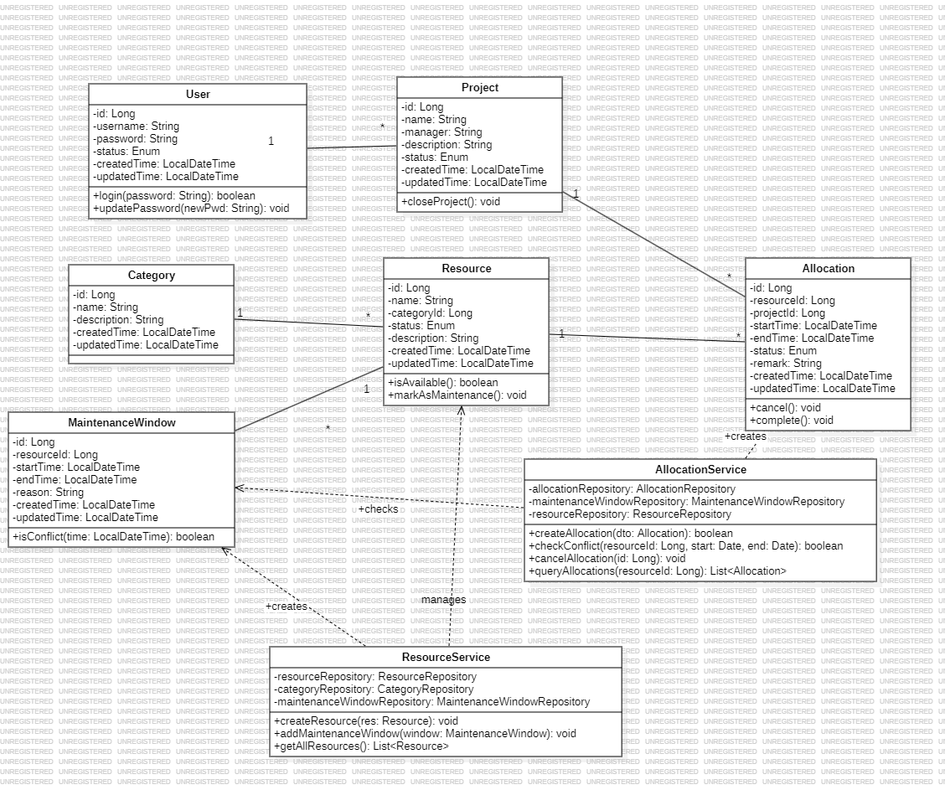
4.2.1 Core Entities
In alignment with the database schema, the system defines the following core entity classes. To ensure data integrity and auditability, all entities inherit primary keys and timestamp fields (creation/update times).
4.2.1.1. User
- Responsibility: Represents the system operator or the project manager responsible for resource allocation.
- Attributes:
  - id: Unique identifier (Long).
  - username: System login credential.
  - password: Encrypted authentication string.
  - role: Authorization level (ADMIN/USER).
  - createdTime / updatedTime: Audit timestamps.
- Relationships:
  - One-to-Many association with Project (functioning as the project manager).
4.2.1.2. Category
- Responsibility: Categorizes enterprise assets to facilitate management (e.g., Computing Resources, Physical Spaces).
- Attributes:
  - id: Unique identifier.
  - name: Designation of the category.
  - description: Functional description.
  - createdTime / updatedTime: Audit timestamps.
- Relationships:
  - One-to-Many association with Resource.
4.2.1.3. Resource
- Responsibility: Represents the core physical or virtual assets owned by the enterprise.
- Attributes:
  - id: Unique identifier.
  - name: Asset designation.
  - status: Current operational state (AVAILABLE, MAINTENANCE, or RETIRED).
  - categoryId: Foreign key referencing the parent category.
  - createdTime / updatedTime: Audit timestamps.
- Relationships:
  - Many-to-One association with Category.
  - One-to-Many association with Allocation (maintains historical usage records).
  - One-to-Many association with MaintenanceWindow (tracks downtime logs).
4.2.1.4. Project
- Responsibility: Represents the consumer entity requiring resource allocation.
- Attributes:
  - id: Unique identifier.
  - name: Project title.
  - manager: Reference to the responsible User.
  - status: Lifecycle state (ACTIVE, COMPLETED, or CANCELLED).
  - createdTime / updatedTime: Audit timestamps.
- Relationships:
  - One-to-Many association with Allocation.
  - Many-to-One association with User.
4.2.1.5. Allocation
- Responsibility: The pivotal business object recording the assignment of a specific resource to a project over a defined time interval.
- Attributes:
  - id: Unique identifier.
  - startTime: Commencement of the reservation.
  - endTime: Conclusion of the reservation.
  - status: Current validity of the record (ACTIVE, CANCELLED, or COMPLETED).
  - remark: Annotation for the allocation request.
  - resourceId: Reference to the allocated asset.
  - projectId: Reference to the requesting project.
  - createdTime / updatedTime: Audit timestamps.
- Constraint: The startTime must strictly precede the endTime.
4.2.1.6. MaintenanceWindow
- Responsibility: Logs periods during which a resource is unavailable due to non-project factors (e.g., repairs, system upgrades).
- Attributes:
  - id: Unique identifier.
  - startTime / endTime: Duration of the maintenance.
  - type: Classification of the conflict (HARD implies total unavailability; SOFT implies a warning).
  - reason: Justification for the downtime.
  - resourceId: Reference to the target asset.
  - createdTime / updatedTime: Audit timestamps.
4.2.2 Business Services
4.2.2.1. AllocationService
- Responsibility: Orchestrates resource scheduling requests and executes conflict validation logic.
- Dependencies:
  - allocationRepository: Manages persistence for allocation records.
  - maintenanceWindowRepository: Accesses maintenance logs for conflict verification.
  - resourceRepository: Validates asset existence.
- Key Operations:
  - createAllocation(Allocation dto): A transactional method that initializes a new allocation request.
  - checkConflict(resourceId, start, end): The core algorithm used to detect temporal overlaps.
  - cancelAllocation(id): Terminates an active allocation and releases the resource.
4.2.2.2. ResourceService
- Responsibility: Manages the lifecycle of asset data and maintenance statuses.
- Dependencies:
  - resourceRepository: Handles CRUD operations for assets.
  - categoryRepository: Validates category associations.
  - maintenanceWindowRepository: Persists new maintenance schedules.
- Key Operations:
  - createResource(Resource res): Onboards new enterprise assets.
  - addMaintenanceWindow(MaintenanceWindow win): Defines and logs maintenance periods

4.3Core Business Logic Design

4.4 Database Design (Schema)
The system utilizes a MySQL database. The design of the core table structures is detailed below:
    - Core Data Tables
4.4.1.1 t_resource (Resource Table)
  - id (BIGINT, PK): Unique identifier for the resource.
  - name (VARCHAR): Name of the resource.
  - category_id (BIGINT, FK): The category to which the resource belongs.
  - status (VARCHAR): Current status of the resource (AVAILABLE, MAINTENANCE, or RETIRED).
  - description (VARCHAR): Detailed description of the resource.
4.4.1.2 t_project (Project Table)
  - id (BIGINT, PK): Unique identifier for the project.
  - name (VARCHAR): Name of the project.
  - manager (VARCHAR): The person responsible for the project.
  - description (VARCHAR): Detailed description of the project.
  - status (VARCHAR): Current status of the project (ACTIVE, COMPLETED, or CANCELLED).
4.4.1.3 t_allocation (Resource Allocation Table - Core)
  - id (BIGINT, PK): Unique identifier for the allocation record.
  - resource_id (BIGINT, FK): Reference to the allocated resource.
  - project_id (BIGINT, FK): Reference to the project requesting the resource.
  - start_time (DATETIME): Start time of the allocation.
  - end_time (DATETIME): End time of the allocation.
  - status (VARCHAR): Status of the allocation record.
  - Constraint: CHECK (end_time > start_time) ensures the validity of the time interval.
4.4.1.4 t_maintenance_window (Maintenance Window Table)
  - id (BIGINT, PK): Unique identifier for the maintenance record.
  - resource_id (BIGINT, FK): Reference to the resource undergoing maintenance.
  - start_time / end_time (DATETIME): The duration of the maintenance period.
  - type (VARCHAR): Type of conflict (HARD for blocking, SOFT for warning).
4.4.1.5 t_user (User Table)
  - id (BIGINT, PK): Unique identifier for the user.
  - username (VARCHAR): System login username.
  - password (VARCHAR): Encrypted password.
  - role (VARCHAR): User role (ADMIN or USER).
4.4.2 Index Design (Indexes)
To optimize the performance of the conflict detection algorithm, the following key index has been established:
- idx_resource_time: A composite index on (resource_id, start_time, end_time) is created for both the t_allocation and t_maintenance_window tables. This index is designed to accelerate queries for checking time overlaps.

